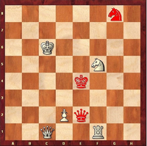
Summary of the chess game of Lewis CARROLL
The white pawn (Alice) plays and wins in 11 moves
The animated diagram

Contents
1) The context
It is impossible to understand the hidden code in this game without knowing a little more about the context! Lewis CARROLL, Alice LIDDELL, their environment and the guidelines to understand the game.

2) The game itself, as written by L. CARROLL (diagram and moves)
3) An unsolved game during 136 years ...

4) Main codes of the game summarized
4.1 – The pieces
4.2 – Their colors
4.3 – Number of moves
4.4 – Hidden initials and presence of the author
4.5 – Moves 6 et 7
4.6 – The altar and the 42
4.7 – No Bishop
4.8 – Poetic signature
4.9 – The number 42
4.10 – Esotericism and mathematics

5) Links and additional documents

1) Context of the game summarized

Charles Lutwidge DODGSON, better known as Lewis CARROLL (1832-1898), was a british writer, photographer and mathematician. Son of a pastor, left-handed and stammerer, first-born in a family of 11 children, he was made deacon. He was a genius in mathematics, highly skilled in symbolic logic, and had a well-developped artistic sense for drawing, theatre, photography (some of his photographies were among the best during the 19th century). He wrote two best-sellers: Alice’s adventures in Wonderland (1865) and its following Through the Looking Glass (1871). He became professeur in mathematics in Christ Church in 1855. His favourite number was 42. | 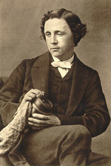

Alice Pleasance LIDDELL (1852-1934), inspired L. CARROLL for Alice’s adventures in Wonderland. She was the daughter of the Dean LIDDELL, manager of the Christ Church College from 1855, which he supervised in a tough way. L.CARROLL met her in 1856. In 1862, Lewis and a friend of his offer a boat walk to 3 LIDDELL sisters, during which he established the guidelines of the stories that Alice will ask him to write. But in 1863, L. CARROLL and the LIDDELLS parted.  Alice became an artist (drawing, painting). She was said to have an affair with prince Leopold, son of Queen Victoria. In 1928, she had important financial difficulties, therefore she was forced to sell the original copy of Alice's adventures under ground that DODGSON gave her. | 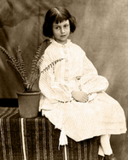

Victorian society
The story takes place during the reign of Queen Victoria (19th century), who stayed 64 years as the head of the british Empire. At that time, you could legally propose to a young lady after her 12th birthday. The ladies were married early, generally before 18 years old.

Main locations
Christ Church College, Oxford university, managed a while by Alice’s father, and where Charles DODGSON worked. (Also, the film Harry Potter took place there).
The Crystal Palace, which once received the World Fair, where Lewis and Alice went and first saw the Queen through mirrors. Mrs LIDDELL also frequently went there to start and built a royal future for her daughter.
The Isis, branch of the River Thames, where Lewis CARROLL sailed with Alice and her sisters.
The White Tower of London, infamous prison near the Queen’s flat.

2) The chess game

And here is the diagram which introduces the tale:

The white pawn (Alice) plays and wins in 11 moves
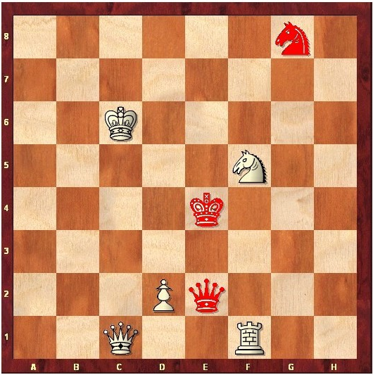

1 Alice meets red Queen 1 £h5 – The red Queen moves to h5

2 Alice through d3 (by railway) 2 £c4 - The white Queen (after shawl)
moves to d4 (Tweedledum et Tweedledee) moves to c4

3 Alice meets white Queen (with shawl) 3 £c5 (the white Queen becomes sheep)

4 Alice moves to d5 (shop, river, shop) 4 £f8
(the white Queen leaves egg on shelf)

5 Alice moves to d6 (Humpty Dumpty) 5 £c8 (flying from the red Knight)

6 Alice moves to d7 (forest) 6 ¤e7+ - The red Knight moves to e7 (check)

7 ¤xe7 – White Knight takes red Knight 7 ¤f5 - The white Knight moves to f5

8 Alice moves to d8 (coronation) 8 £e8 - Red Queen moves to e8 (examination)

9 Alice becomes Queen 9 Queens castle

10 Alice castles (feast) 10 £a6 (soup)

11 Alice takes red Queen, and wins. £xe8 checkmate.

3) An unsolved game during 136 years ...

Preface of 1896: 25 years after Through the Looking Glass was published, and two years before he died, Lewis CARROLL, noticing the global scepticism and lack of understanding in the face of his chess problem, wrote a preface in order to specify some points about it ... Nothing really useful, but still, he wrote it on purpose ...
See the preface in additional documents.

Christophe LEROY, born in 1968, is a chess fan and a good player (rated around 2200 pts) tireless worker since 1984, general delegate of the Lyon Olympique Echecs since 1992. He was asked in 1999 by the NOAO to comment this chess game, though he had never heard of it before. He worked hard on several french and english articles. He realized that this game had never really been read or solved properly .… After many unsuccessful studies, everything appeared clear overnight: Christophe understood that each piece was actually a living person during CARROLL’s life. Following that, a whole adventure began to figure out what Lewis CARROLL meant. It led him to Oxford, London, Paris and many other towns, and allowed him to meet dozens of people worldwide.

Needless to say, the complexity of this problem kept many chess players from trying to understand! Alice (white pawn) plays and wins but red pieces act first ... The whites play 14 times, the blacks only 3 ... A pawn which reaches the last square does not promote immediately ... And to crown it all, a King stays in check for two moves ... Christophe likes to say that normally non chessplayers flee in front of a chess problem and that chessplayers flee in front of such an odd position!

In December 2006, 70% of the game were decoded. Convinced that this game was really poetic and deserved to be known and recognized, Christophe claimed: “I consider it as part of the “world literary inheritance”, with the feeling to have finally found a precious text of the English author … allowing us to have a truly different reading than the one usually found in Through the looking glass and what Alice found there. A giant chessboard of mirrors with the position of the game was exposed during 4 months in domaine of Lacroix-Laval near Lyon, where several conferences took place.

In March 2008, his book explaining the game, Alice et le maître d’échecs, was published by the URDLA. In may 2008, Christophe received two letters coming from two world specialists of L. CARROLL’s work:
- Edward WAKELING, the master of 42!
- Professor M. COHEN, who wrote a key book on Lewis CARROLL. He indicated that he was very happy that this game helps to understand the relationship between the LIDDELL family and Lewis CARROLL.
The Lewis CARROLL Societies in London (Mark RICHARDS) and New York (Clare IMHOLTZ) have congratulated him on his work and the Christ Church College added his book to its library. The missing element?
Finally, in June 2008, he grabbed the opportunity to explain this game to former world chess champion A. KARPOV in the flat of the painter M. SCHOENDORFF (who is the editor of Alice et le maître d’échecs).

4) Main codes of the game summarized
Always keep the position of the game in mind, and if possible the animated diagram or a chessboard to play the moves! And make sure to be well seated ...
Learn Lewis CARROLL’s language

4.1 – The pieces
Each piece embodies a real person:
- The white Pawn is Alice LIDDELL (indicated by the author),
- The white Knight is probably a messenger sent by Lewis CARROLL, trying to become Alice’s dearest knight.
- The red Knight embodies Charles LUTWIDGE DODGSON, who also becomes the white Knight during the 6th and 7th moves.
- The white King is Alice’s father (Mr LIDELL).
- The white Queen is Alice’s mother (Mrs LIDDELL).
- The red Queen symbolizes Queen Victoria (and not Mrs PRICKETT, Alice's housekeeper)
- The red King is the mystery, the part of dreams we all have in us. It embodies Charles L. DODGSON dreaming about the young Alice and all the adventure. He uses both knights to deliver his message ...
- The white Rook is the White Tower (an infamous prison in London), symbolizing the conservative Victorian society during the 19th century (the white Knight appears like a prisoner of this tower).

Let us take a look at the initial position:
- Let us imagine that the white Queen (Mrs LIDDELL) holds Alice (white Pawn) by the hand while observing the Victorian society (white Rook).
- Queen Victoria (the red Queen) stands above the white rook, and talks with Alice. She begins the game.
- We will come back on the position of the Knight in g8 in paragraph 4.4.
- Let us also notice that the white King (Mr LIDDELL) is in diagonal opposition with the red King (the dreaming C. L. DODGSON), who holds by the hand the white Knight, his messenger. Just as in the author’s true life, where he is in conflict with Alice’s father. That was one of the first things that put C. LEROY on the right track!

Now you can replay the game, with new eyes ... Several codes can almost be found at each move.
4.2 – Pieces' colors
The choice of colors (white and red) of the pieces is important.
The opposition between black and white pieces in chess was turned into red and white: passion-softness, fire-snow.
Red symbolizes passion, love and hatred with all that it involves.
White represents softness, marriage, nobility, virginity and purity: Alice, but also what the british society was faking.

4.3 – Number of moves
The white pieces play 13 times and several moves successively whereas the black pieces only play 3 times. An element which has disconcerted many chessplayers for over a century!

There are 13 white moves but in fact 14. The author lays the emphasis (in the text commenting the second move) on the fact that Alice’s first move as a white Pawn counts as two, since she moves from d2 to d3 by the railroad then reaches d4. Therefore there are 14 white moves and 3 black ones. 14 x 3 = 42, that is to say L. CARROLL’s favourite number!

4.4 – Hidden initials and presence of the author
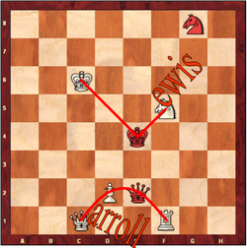
Let us first imagine the hidden initials of Lewis CARROLL (L and C) in the following position, just to see an example of how deep the author thought it out ... Let us observe that the only piece not concerned by this “signature” is the red Knight.

One might notice that this red Knight is on the g8 square, that means there are 7 empty squares on the g-file and 6 empty squares on his left. Actually L. CARROLL lived from 1868 in the square-like Christ Church, in a flat number 6 where people could only access through the stairs number 7 (6 x 7 = 42!). Besides, only the red Knight checks the white King during the game and, since the check is written “+”, it may well embody the sacred cross of the deacon Charles L. DODGSON.

Is Lewis CARROLL not giving us signs of his presence?
4.5 – Moves 6 et 7
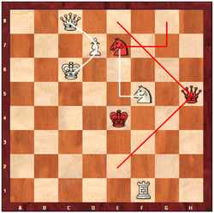
6. The red Knight plays in e7 (check).

Now, let us look at the 6th and 7th moves ( 6 x 7 = 42! ), as indicated in the preface of 1896 ... (… but the "check" of the White King on move 6, the capture of the Red Knight on move 7, (...) will be found to be strictly in accordance with the laws of the game ...)
It's the most important sequence of the game.

6 Alice moves to d7 (forest) 6 ¤e7+ - The red Knight moves to e7 (check)
7 ¤xe7 - White Knight takes red Knight 7 ¤f5 - The white Knight moves to f5

Signature of the writer or drawer
The red Knight goes to e7. The white Knight takes in e7. The white Knight goes back to f5: 3 moves in form of L: L like Lewis, Love and LIDDELL!
The red Knight in e7 gives check (+) to the King and Queen while talking to Alice.
These 3 white pieces might form the C of CARROLL, Charles or Church!
This religious sign reminds that the Deacon dressed in black (red): Charles L. DODGSON, the red Knight.

And watch all the 6 x 7 (= 42) one can find in this following of 4 half-moves ...
Numerous signatures:
The main issue of this game seems to be a decisive discussion between parents (white King and Queen) and a Deacon (red Knight) on the destiny of the young girl Alice (white Pawn).

Wants the red Knight, doing this royal fork, get rid of her parents?
No, the C of CARROLL on the 3 pieces « King, Queen and Pawn » seems rather to point out: « Do you accept that Alice LIDDELL takes the name of CARROLL? ».
Indeed, this sacrifice (he is taken by the white Knight: his double) permits him to do another proposal but with new clothes ... White clothes, symbol of marriage ...

The transformation of the red Knight into a white Knight is therefore a request to enter in the family. Furthermore, becoming white, he takes the same color of the LIDDELL family. (becomes a nobleman?)

4.6 – The altar and the 42
The altar of 42 and the proposal of marriage!
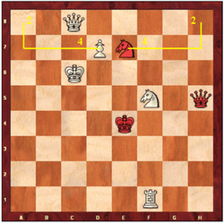
In the chess notation of 19th century, the names of squares depended on which side played.
http://en.wikipedia.org/wiki/Descriptive_chess_notation
Let us notice that in this position:
- The exchange of the 2 Knights is done on the 4th column and 2nd rank of black (= 42!).
The white Pawn (Alice) is on the 4th column of white and 2nd rank of black. Another 42 in mirror!
- These 2 squares are forming a rectangle: the altar of 42 where takes place the proposal of marriage!

This proposal fails because on the next move the white Knight takes his place back in f5: « Go back to your dreams Mr CARROLL! ».

The end of the route of red Queen (V = Victoria) explains the reason of the refusal: Alice was promised to a member of the royal family. When the red Queen arrives on the e8 square, she examines the LIDDELL family: Alice, the white Queen and the white King, while observing the red King dreaming of all this adventure.

4.7 – No Bishop
One may notice that there is no Bishop in the game, it is the only missing piece. It seems like L. CARROLL willingly kept it out. Is that due to his doubts concerning religion during his life, or to his respect towards it?
No! Since the request has been refused, there is no marriage!

4.8 – Poetic signature

Poetic signature: Charles and Alice together for the eternity

9. Alice becomes Queen
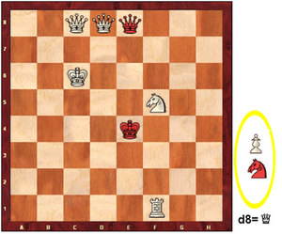
This transformation of Alice into a white Queen marks the end of the « adult-child » relationship between Charles L. DODGSON and Alice.
Alice (white Pawn) transforms into a Queen (into a woman) and disappears from the board (« You should stop when 7-years-old! »). Remember that the author (red Knight) has disappeared before too. Nice poetic instant when the two friend, Charles L. DODGSON and Alice meet again together for the eternity off the board ... Nobody will be able to steal their wonderful « adult-child » story.

4.9 – The number 42
There is another important mention of the number 42.
This hidden signature strongly confirms the identity of the author whose favourite number was 42.
So, here are the values of chess pieces:
Pawn: 1 point
Knight: 3 points
Bishop: 3 points
Rook: 5 points
Queen: 10 points (19th century)
King: The game!

Back to the last diagram. The sum on the board is 10 + 10 + 10 + 5 + 3 = 38 points. The sum out of the board is 3 + 1 = 4 points. 38 + 4 = 42 points! It's hard for a chessplayer to have the idea of counting points on and out of the board! A major, hidden and impressive signature!

4.10 – Esotericism and mathematics
Moreover if one come back to the moves of the game proposed by the author, one will see that he has certainly done 2 columns on purpose: one of 11 half-moves and the other of 10 half-moves, which makes 10+11 half-moves = 21 half-moves on 2 columns = 42! We underline, while we are at it, that Lewis CARROLL has 20 years and a half more than Alice (20 half-moves and one half-move!) and 20 years and a half less than the Dean LIDDELL, Alice's father ...

Numbered diaries of Charles L. DODGSON have mysteriously disappeared on the 13 existents: numbers 1, 3, 6 and 7.
So, it's funny to note that in the chess game which interests us:
- The Pawn (Alice) = 1 point, the disappeared diary number 1.
- One red or white Knight (Charles L. DODGSON or Lewis CARROLL) = 3 points, the disappeared diary number 3.
- One white Knight (Lewis CARROLL) + one red Knight (Charles L. DODGSON) = 6 points, the disappeared diary number 6.
- One white Knight (Lewis CARROLL) + one red Knight (Charles L. DODGSON) + the Pawn (Alice) = 7 points, the disappeared diary number 7. Coincidence?
When Charles DODGSON died, the notary is said to have destroyed these diaries on CARROLL's behalf ... But it stays quite mysterious.

Esotericism and coincidences
Lewis CARROLL met Alice when he was 24 and died 42 years later.
In 1856, the year he met Alice, he took his pseudonym, began photography, which he quitted suddenly 24 years later!
The age of the Queens in Alice is 101 years, 5 months and 1 day, which is 37044 days (with 24 leap years). There are 2 Queens, so 37044 x 2 = 74 088. 74088 = 42 x 42 x 42 ... (more details in the document about the 42)
The NOAO exhibition about L. CARROLL (it prompted the begin of C. LEROY's searches) started on 15th of June 1999 which is 101 years, 5 months and 1 day after his death (January 14th 1898).
And numerous others ...

Additional remark
One word to say that during the most intense periods of searches, Christophe often had to deal with the number 42 or with numbers of missing diaries. One word because it would be impossible to summarize it!

5) Links and additional documents

Animated diagram:
http://www.echecs-histoire-litterature.com/images/diag.gif
Preface of 1896:
http://www.echecs-histoire-litterature.com/docs/preface_fr.doc
Former world champion Anatoly KARPOV discovering the chess game:
http://www.lyon-olympique-echecs.com/textes/textes/accueil/photos_karpov_carroll.html
Article Cote-Lyon (French / English):
http://www.echecs-histoire-litterature.com/presse/cotelyon.pdf
The 42, Lewis CARROLL's favourite number (in French):
http://www.echecs-histoire-litterature.com/42.html

2007 presse review: http://www.echecs-histoire-litterature.com/presse.html
Press release of June 3rd
Press release of June 25th
Press release of July 3rd

Photos:
LEROY and CARROLL in photo:
http://www.echecs-histoire-litterature.com/photos/christchurch/christchurchhall_004.jpg
Lewis CARROLL's favorite bird, the dodo:
http://www.echecs-histoire-litterature.com/photos/dodo.jpg

Photos galleries:
CARROLL and Alice in Christ Church's stained-glass windows:
http://www.echecs-histoire-litterature.com/vitraux.html
Fresco the lion and the unicorn:
http://www.echecs-histoire-litterature.com/photos_fresque.html
White Tower of London:
http://www.echecs-histoire-litterature.com/photos_tourblanche.html
Godstow near Oxford:
http://www.echecs-histoire-litterature.com/photos_godstow.html
The Isis, branch of River Thames:
http://www.echecs-histoire-litterature.com/fleuves.html
Christ Church's hall:
http://www.echecs-histoire-litterature.com/christchurchhall.html
Outside of Christ Church:
http://www.echecs-histoire-litterature.com/christchurch.html
Giant chessboard of mirrors:
http://www.echecs-histoire-litterature.com/photos_semaine3.html
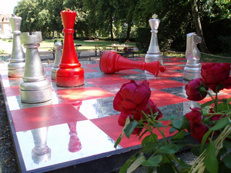

Links
Official website Alice and the chess master: http://www.echecs-histoire-litterature.com/index_english.html
Lewis CARROLL in a word: http://www.echecs-histoire-litterature.com/eng/lewiscarroll.doc
Personalized stamp: http://www.echecs-histoire-litterature.com/eng/stamp.doc
Lewis CARROLL Society of London: http://lewiscarrollsociety.org.uk/
Lewis CARROLL Society of North America: http://www.lewiscarroll.org/
Lewis CARROLL Yahoo Group list of discussion: http://groups.yahoo.com/group/lewiscarroll/
Alices's Shop in Oxford: http://www.aliceinwonderlandshop.co.uk/
Alices's Shop photos: http://www.echecs-histoire-litterature.com/aliceshop.html
Learn to play chess with Alice (in French):
http://www.echecs-histoire-litterature.com/docs/regles_alice.pdf
Book Alice et le maître d'échecs http://www.urdla.com/livre/hurdle_leroy.htm
Excerpts of our conferences: http://www.echecs-histoire-litterature.com/conference.html
More codes and information: http://www.echecs-histoire-litterature.com/eng/press_book.doc
Excerpts of the book : http://www.echecs-histoire-litterature.com/eng/throughtlg_ex.doc

Wikipédia
http://en.wikipedia.org/wiki/Lewis_carroll
http://en.wikipedia.org/wiki/Alice_Liddell
http://en.wikipedia.org/wiki/Alice%27s_Adventures_in_Wonderland
http://en.wikipedia.org/wiki/Through_the_Looking-Glass%2C_and_What_Alice_Found_There
http://en.wikipedia.org/wiki/John_Tenniel

Winks at authors (in French)
H. RINK http://www.echecs-histoire-litterature.com/docs/rinck.doc
M. DUCHAMP http://www.echecs-histoire-litterature.com/docs/duchamp.doc

